OSPF Redistribution

In this lab we will configure redistribution of different routes into OSPF and RIP. We will introduce filtering using a route-map and a distribute-list.
This lab can be configured using the Physical lab, GNS3 or VIRL.Packet Tracer does not support the required redistribution commands.
Note: It is usually best practice to choose a single method for filtering routes. Distribute-lists are simpler and easier to apply while route-maps are more powerful and flexible and can be used to more than just permit or deny a route.

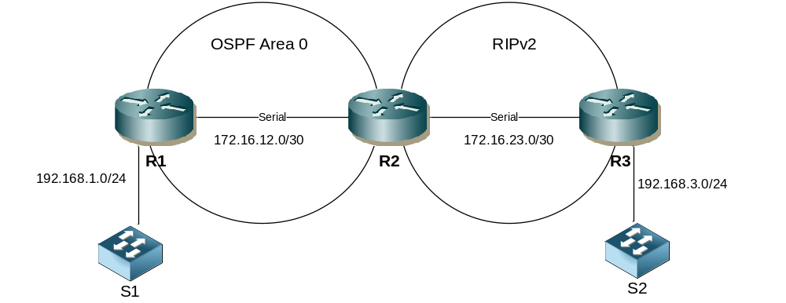

Step 1 - Physical
- Cable up the lab network as per the topology diagram.
- The routers can be 1841 or 1941 models.
- Use serial or Ethernet cables between the routers. If using serial, you decide which end will be DCE.

Step 2 – IP addressing
- Configure IP addressing as follows. You decide on the actual device addresses
R1 LAN | 192.168.1.0/24
R1 – R2 Serial | 172.16.12.0/30
R2 – R3 Serial | 172.16.23.0/30
R3 LAN | 192.168.3.0/24

Step 3 – Configure OSPF
- Set the router-ids to be x.x.x.x where x is the router number.
- Ensure the correct interfaces are running OSPF between R1 & R2.
- Make all LAN interfaces passive.

Step 4 – Configure RIP
- Configure RIPv2 between R2 & R3
- Ensure auto summarization is disabled

Step 4 – Add static routes to R1

- Configure the following static routes on R1. Null0 represents a virtual interface that will discard packets it receives. These are often used to advertise a summary route when more routes to more specific destinations exist. In this instance the null0 destination is used to simulate remote networks in the same way similar to how we often use loopback interfaces.
R1(config)#ip route 200.2.0.0 255.255.255.0 null 0
R1(config)#ip route 200.2.1.0 255.255.255.0 null 0
R1(config)#ip route 200.2.2.0 255.255.255.0 null 0
R1(config)#ip route 200.2.3.0 255.255.255.0 null 0
R1(config)#ip route 100.1.1.0 255.255.255.240 null 0
R1(config)#ip route 100.1.1.16 255.255.255.240 null 0
R1(config)#ip route 100.1.1.32 255.255.255.240 null 0
R1(config)#ip route 100.1.1.48 255.255.255.240 null 0

Step 4 – Redistribute the statics into OSPF
- Redistribute the statics into OSPF
- Ensure to include subnets
- Confirm the routes are present in R2s route table
- What type of OSPF routes are these?

Step 5 - Configure loopback addresses on R3
- Configure the following loopback interfaces and IP addresses on R3
lo0 | 32.10.10.1/24
lo1 | 32.20.20.1/24
lo2 | 32.30.30.1/24
lo3 | 32.30.30.1/24

Step 6 Redistribute the loopbacks into RIP
- Set a default metric of 5 under RIP on R3
- Redistribute the loopback addresses into RIP on R3
- Confirm the routes are present in R2s route table
- What is the metric for these routes on R2?

Step 7 Redistribute OSPF into RIP on R2
- Configure a default metric under RIP of 3
- Redistribute OSPF into RIP on R2
- Confirm the routes are present on R3

Step 8 Redistribute RIP into OSPF on R2
- Redistribute RIP into OSPF on R2, include subnets, set a metric of 50 and change the external type to 1 within the same redistribution command
- Confirm the routes are present on R3
- What are the cost of the routes on R3

Step 9 Use a route-map to filter static route redistribution
- At this point all 3 routers should see all routes. Now we will introduce methods to filter which routes are advertised and received.
- Create a route-map on R1 that matches only the static route networks starting with 200 (hint match a standard ACL)
route-map static2ospf permit 10
match ip address 1

access-list 1 permit 200.0.0.0 0.255.255.255

- Change the redistribute static command on R1 to include the route-map
  - Note this may require clearing the OSPF process
router ospf 1
redistribute static route-map static2ospf subnets

clear ip ospf process

- Confirm the static routes starting with 100 are no longer present on R2

Step 10 Use a route-map to filter loop back redistribution
- Create a route-map on R3 that matches only lo1 & lo2 (hint you can match the ip address or you can match interface).
- Change the redistribute static command on R3 to include the route-map
- Confirm the routes for networks matching lo0 & lo3 are no longer present on R2

Step 11 Use a distribute-list to filter routes received and advertised by RIP
- A distribute-list can be used to filter outbound or inbound routes. This does not work well with OSPF however as though it can prevent the route being installed into the route table it does not prevent LSAs from being learned or advertised. Here we will use it with RIP to prevent some routes from being learned (perhaps as they may cause sub optimal routing).
- Configure RIP on R3 with an inbound distribute list preventing 200.2.2.0/24 network from being learned.
access-list 2 deny 200.2.2.0 0.0.0.255
access-list 2 permit any

router rip
distribute-list 2 in

Challenge
- Tagging routes is one way to prevent route feedback issues. If hyperthetically R3 was able to advertise its routes to R1 via another path then a loop could potentially exist.
- Change the redistribution of OSPF into RIP on R2 so that a tag value of 666 is applied to all redistributed routes (hint use the set command within a route-map)
- Change the redistribution of RIP into OSPF on R2 so that routes with a TAG value of 666 are not permitted. (Hint use the match command within a route-map)

